Câu 1: Sử dụng ngôn ngữ VHDL mô tả hệ thống số như sau:
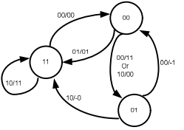
library ieee;
use ieee.std_logic_1164.all;
entity cau_1 is
port (
clk: in std_logic;
input: in std_logic_vector (1 downto 0);
output: out std_logic_vector(1 downto 0)
);
end entity cau_1;
-- A0: "00"
-- A1: "01"
-- A2: "11"
architecture behavioral of cau_1 is
type stage is (A0, A1, A2);
signal current_stage, next_stage: stage;
begin
--=======================================
--Tinh trang thai ke tiep va gia tri ra
--=======================================
caculating_stage : process (clk) is
begin
if rising_edge(clk) then
case current_stage is
when A0 =>
case input is
when "01" => next_stage <= A2;
output <= "01";
when "00" => next_stage <= A1;
output <= "11";
when "10" => next_stage < = A1;
output <= "00";
end case;
when A1 =>
case input is
when "00" => next_stage <= A0;
output(1) <= '-';
output(0) <= '1';
when "10" => next_stage <= A2;
output(1) <= '-';
output(0) <= '0';
end case;
when A2 =>
case input is
when "10" => next_stage <= A2;
output <= "11";
when "00" =>
next_stage <= A0;
output <= "00";
end case;
end case;
end if;
end process caculating_stage;
current_stage <= next_stage;
end architecture behavioral;

Câu 2: Sử dụng ngôn ngữ VHDL mô tả hệ thống số như sau:
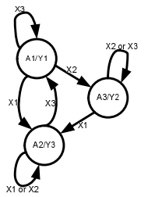
library ieee;
use ieee.std_logic_1164.all;

entity cau_2 is
port (
clk: in std_logic;
input: in std_logic_vector(1 downto 0);
output: std_logic_vector(1 downto 0)
);

end entity cau_2;

-- X1 = "01"
-- X2 = "10"
-- X3 = "11"
-- Y1 = "01"
-- Y2 = "10"
-- Y3 = "11"
architecture behavioral of cau_2 is
type stage is (A1, A2, A3);
signal current_stage, next_stage: stage;

begin
--=======================================
-- TINH TRANG THAI KE TIEP
--=======================================
calc_stage: process (clk) is
begin
if rising_edge(clk) then
case current_stage is
when A1 =>
case input is
when "01" => next_stage <= A2;
when "10" => next_stage <= A3;
when "11" => next_stage <= A1;
end case;
when A2 =>
case input is
when "01" => next_stage <= A2;
when "10" => next_stage <= A2;
when "11" => next_stage <= A1;
end case;
when A3 =>
case input is
when "01" => next_stage <= A2;
when "10" => next_stage <= A3;
when "11" => next_stage <= A3;
end case;
end case;
end if;
end process calc_stage;

--=============================================
-- TINH GIA TRI RA
--=============================================
calc_output: process (current_stage) is
begin
case current_stage is
when A1 => output <= "01";
when A2 => output <= "11";
when A3 => output <= "10";
end case;
end process calc_output;

--=======================================
-- CHUYEN TRANG THAI
--======================================
current_stage <= next_stage;
end architecture behavioral;

Câu 3: Sử dụng ngôn ngữ VHDL mô tả hệ thống số như sau:
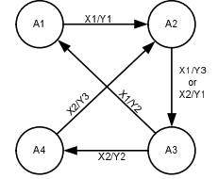

library ieee;
use ieee.std_logic_1164.all;

entity cau_3 is
port (
clk : in std_logic;
input: in std_logic;
output : out std_logic_vector(1 downto 0)
);
end entity cau_3;

-- X1 = '0'
-- X2 = '1'
-- Y1 = "01"
-- Y2 = "10"
-- Y3 = "11"
architecture behavioral of cau_3 is
type stage is (A1, A2, A3, A4);
signal current_stage, next_stage: stage;

begin
--=================================
-- TINH TRANG THAI KE TIEP
--=================================
calc_stage : process (clk) is
begin
if rising_edge(clk) then
case current_stage is
when A1 => if input= '0' then
next_stage <= A2;
output <= "01";
end if;
when A2 => if input = '0' then
next_stage <= A3;
output <= "11";

elsif input = '1' then
next_stage <= A3;
output <= "01";
end if;
when A3 => if input = '0' then
next_stage <= A1;
output <= "10";
elsif input = '1' then
next_stage <= A4;
output <= "10";
end if;
when A4 => if input= '1' then
next_stage <= A2;
output <= "11";
end if;
end case;
end if;
end process calc_stage;
--==================================
-- CHUYEN TRANG THAI
--==================================
current_stage <= next_stage;
end architecture behavioral;

Câu 4: Sử dụng ngôn ngữ VHDL mô tả hệ thống số như sau:
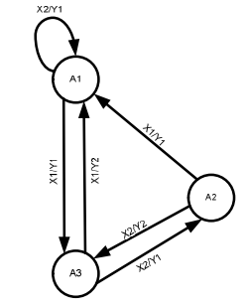

library ieee;
use ieee.std_logic_1164.all;

entity cau_4 is
port (
clk : in std_logic;
input: in std_logic;
output : out std_logic

);
end entity cau_4;
-- X1 = '0'
-- X2 = '1'
-- Y1 = "0"
-- Y2 = "1"

architecture behavioral of cau_4 is
type stage is (A1, A2, A3);
signal current_stage, next_stage: stage;

begin
--=================================
-- TINH TRANG THAI KE TIEP
--=================================
calc_stage : process (clk) is
begin
if rising_edge(clk) then
case current_stage is
when A1 => if input= '0' then
next_stage <= A3;
output <= '0';
elsif input = '1' then
next_stage <= A1;
output <= '0';
end if;
when A2 => if input = '0' then
next_stage <= A1;
output <= "0";
elsif input = '1' then
next_stage <= A3;
output <= "1";
end if;
when A3 => if input = '0' then
next_stage <= A1;
output <= "1";
elsif input = '1' then
next_stage <= A2;
output <= "0";
end if;
end case;
end if;
end process calc_stage;

--==================================
-- CHUYEN TRANG THAI
--==================================
current_stage <= next_stage;
end architecture behavioral;

Câu 5: Sử dụng ngôn ngữ VHDL mô tả hệ thống số như sau:
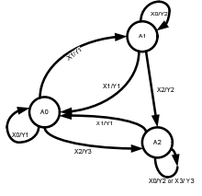

library ieee;
use ieee.std_logic_1164.all;

entity cau_5 is
port (
clk: in std_logic;
input: in std_logic_vector (1 downto 0);
output: out std_logic_vector(1 downto 0)
);

end entity cau_5;

-- X0 = "00"
-- X1 = "01"
-- X2 = "10"
-- X3 = "11"
-- Y1 = "01"
-- Y2 = "10"
-- Y3 = "11"
architecture behavioral of cau_5 is
type stage is (A0, A1, A2);
signal current_stage, next_stage: stage;

begin
--=======================================
--TINH TRANG THAI KE TIEP
--=======================================
calc_stage : process (clk) is
begin
if rising_edge(clk) then
case current_stage is
when A0 =>
case input is
when "00" => next_stage <= A0;
output <= "01";
when "01" => next_stage <= A1;
output <= "11";
when "10" => next_stage <= A2;
output <= "11";
end case;
when A1 =>
case input is
when "00" => next_stage <= A1;
output <= "10";
when "01" => next_stage <= A0;

output <= "01";
when "10" => next_stage <= A2;
output <= "10";
end case;
when A2 =>
case input is
when "00" => next_stage <= A2;
output <= "10";
when "01" => next_stage <= A0;
output <= "01";
when "11" => next_stage <= A2;
output <= "11";
end case;
end case;
end if;
end process calc_stage;
--========================
-- CHUYEN TRANG THAI
--========================
current_stage <= next_stage;
end architecture behavioral;

Câu 6: Sử dụng ngôn ngữ VHDL mô tả hệ thống số như sau:
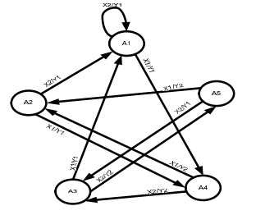

library ieee;
use ieee.std_logic_1164.all;

entity cau_6 is
port (
clk: in std_logic;
input: in std_logic;
output: out std_logic
);

end entity cau_6;

-- X1 = "0"
-- X2 = "1"

-- Y1 = "0"
-- Y2 = "1"

architecture behavioral of cau_6 is
type stage is (A1, A2, A3, A4, A5);
signal current_stage, next_stage: stage;
begin
--=======================================
--TINH TRANG THAI KE TIEP
--=======================================
calc_stage : process (clk) is
begin
if rising_edge(clk) then
case current_stage is
when A1 =>
if input= '0' then
next_stage <= A4;
output <= '0';
elsif input= '1' then
next_stage <= A1;
output <= '0';
end if;
when A2 =>
if input= '0' then
next_stage <= A4;
output <= '1';
elsif input= '1' then
next_stage <= A1;
output <= '0';
end if;
when A3 =>
if input= '0' then
next_stage <= A1;
output <= '1';
elsif input= '1' then
next_stage <= A5;
output <= '1';
end if;
when A4 =>
if input= '0' then
next_stage <= A2;
output <= '1';
elsif input= '1' then
next_stage <= A3;
output <= '1';
end if;
when A5 =>
if input= '0' then
next_stage <= A2;
output <= '1';
elsif input= '1' then
next_stage <= A3;
output <= '0';
end if;
end case;
end if;
end process calc_stage;

--========================
-- CHUYEN TRANG THAI
--========================
current_stage <= next_stage;
end architecture behavioral;

Câu 7: : Sử dụng ngôn ngữ VHDL mô tả hệ thống số như sau:
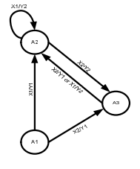

library ieee;
use ieee.std_logic_1164.all;

entity cau_7 is
port (
clk : in std_logic;
input: in std_logic;
output : out std_logic
);
end entity cau_7;

-- X1 = '0'
-- X2 = '1'
-- Y1 = '0'
-- Y2 = '1'
architecture behavioral of cau_7 is
type stage is (A1, A2, A3);
signal current_stage, next_stage: stage;

begin
--=================================
-- TINH TRANG THAI KE TIEP
--=================================
calc_stage : process (clk) is
begin
if rising_edge(clk) then
case current_stage is
when A1 => if input= '0' then
next_stage <= A2;
output <= '0';
elsif input = '1' then
next_stage <= A3;
output <= '0';
end if;
when A2 => if input = '0' then
next_stage <= A2;
output <= '1';
elsif input = '1' then
next_stage <= A3;

output <= '1';
end if;
when A3 => if input = '0' then
next_stage <= A2;
output <= '1';
elsif input = '1' then
next_stage <= A2;
output <= '0';
end if;
end case;
end if;
end process calc_stage;
--==================================
-- CHUYEN TRANG THAI
--==================================
current_stage <= next_stage;
end architecture behavioral;

Câu 8: Sử dụng ngôn ngữ VHDL mô tả hệ thống số như sau:
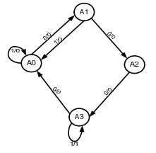

library ieee;
use ieee.std_logic_1164.all;

entity cau_8 is
port (
clk : in std_logic;
input: in std_logic;
output : out std_logic
);
end entity cau_8;

-- X1 = '0'
-- X2 = '1'
-- Y1 = "0"
-- Y2 = "1"
architecture behavioral of cau_8 is
type stage is (A0, A1, A2, A3);
signal current_stage, next_stage: stage;

begin
--=================================
-- TINH TRANG THAI KE TIEP
--=================================

calc_stage : process (clk) is
begin
if rising_edge(clk) then
case current_stage is
when A0 =>
if input = '0' then
next_stage <= A1;
output <= '0';
elsif input = '1' then
next_stage <= A0;
output <= '0';
end if;
when A1 => if input= '0' then
next_stage <= A2;
output <= '0';
elsif input = '1' then
next_stage <= A0;
output <= '0';
end if;
when A2 => if input = '0' then
next_stage <= A3;
output <= '0';
end if;
when A3 => if input = '0' then
next_stage <= A0;
output <= '0';
elsif input = '1' then
next_stage <= A3;
output <= '1';
end if;
end case;
end if;
end process calc_stage;
--==================================
-- CHUYEN TRANG THAI
--==================================
current_stage <= next_stage;
end architecture behavioral;
Câu 9: Sử dụng ngôn ngữ VHDL mô tả hệ thống số như sau:
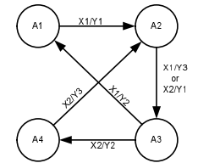
library ieee;
use ieee.std_logic_1164.all;

entity cau_9 is

port (
clk : in std_logic;
input: in std_logic;
output : out std_logic_vector(1 downto 0)
);
end entity cau_9;
-- X1 = '0'
-- X2 = '1'
-- Y1 = "01"
-- Y2 = "10"
-- Y3 = "11"
architecture behavioral of cau_9 is
type stage is (A1, A2, A3, A4);
signal current_stage, next_stage: stage;

begin
--=================================
-- TINH TRANG THAI KE TIEP
--=================================
calc_stage : process (clk) is
begin
if rising_edge(clk) then
case current_stage is
when A1 => if input= '0' then
next_stage <= A2;
output <= "01";
end if;
when A2 => if input = '0' then
next_stage <= A3;
output <= "11";
elsif input = '1' then
next_stage <= A3;
output <= "01";
end if;
when A3 => if input = '0' then
next_stage <= A1;
output <= "10";
elsif input = '1' then
next_stage <= A4;
output <= "10";
end if;
when A4 => if input= '1' then
next_stage <= A2;
output <= "11";
end if;
end case;
end if;
end process calc_stage;

--==================================
-- CHUYEN TRANG THAI
--==================================
current_stage <= next_stage;
end architecture behavioral;

Câu 10: Sử dụng ngôn ngữ VHDL mô tả hệ thống số như sau:
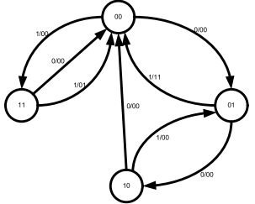
library ieee;
use ieee.std_logic_1164.all;

entity cau_10 is
port (
clk : in std_logic;
input: in std_logic;
output : out std_logic_vector (1 downto 0)
);
end entity cau_10;

-- A0 = "00"
-- A1 = "01"
-- A2 = "10"
-- A3 = "11"
architecture behavioral of cau_10 is
type stage is (A0, A1, A2, A3);
signal current_stage, next_stage: stage;

begin
--=================================
-- TINH TRANG THAI KE TIEP
--=================================
calc_stage : process (clk) is
begin
if rising_edge(clk) then
case current_stage is
when A0 => if input = '1' then
next_stage <= A3;
output <= "00";
elsif input = '0' then
next_stage <= A1;
output <= "00";
end if;
when A1 => if input= '0' then
next_stage <= A2;
output <= "00";
elsif input = '1' then
next_stage <= A0;
output <= "11";
end if;
when A2 => if input = '0' then
next_stage <= A0;
output <= "00";

elsif input = '1' then
next_stage <= A1;
output <= "00";
end if;
when A3 => if input = '0' then
next_stage <= A0;
output <= "00";
elsif input = '1' then
next_stage <= A0;
output <= "01";
end if;
end case;
end if;
end process calc_stage;
--==================================
-- CHUYEN TRANG THAI
--==================================
current_stage <= next_stage;
end architecture behavioral;

Câu 11: Sử dụng ngôn ngữ VHDL mô tả hệ thống số như sau:
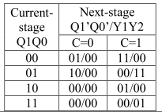
library ieee;
use ieee.std_logic_1164.all;

entity cau_11 is
port (
clk : in std_logic;
input: in std_logic;
output : out std_logic_vector (1 downto 0)
);
end entity cau_11;

-- A0 = "00"
-- A1 = "01"
-- A2 = "10"
-- A3 = "11"

architecture behavioral of cau_11 is
type stage is (A0, A1, A2, A3);
signal current_stage, next_stage: stage;

begin
--=================================
-- TINH TRANG THAI KE TIEP
--=================================
calc_stage : process (clk) is
begin
if rising_edge(clk) then
case current_stage is
when A0 => if input = '1' then

next_stage <= A3;
output <= "00";
elsif input = '0' then
next_stage <= A1;
output <= "00";
end if;
when A1 => if input= '0' then
next_stage <= A2;
output <= "00";
elsif input = '1' then
next_stage <= A0;
output <= "11";
end if;
when A2 => if input = '0' then
next_stage <= A0;
output <= "00";
elsif input = '1' then
next_stage <= A1;
output <= "00";
end if;
when A3 => if input = '0' then
next_stage <= A0;
output <= "00";
elsif input = '1' then
next_stage <= A0;
output <= "01";
end if;
end case;
end if;
end process calc_stage;
--==================================
-- CHUYEN TRANG THAI
--==================================
current_stage <= next_stage;
end architecture behavioral;

Câu 12: Sử dụng ngôn ngữ VHDL mô tả hệ thống số như sau:
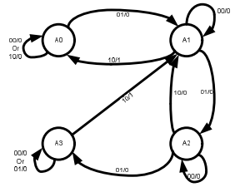

library ieee;
use ieee.std_logic_1164.all;

entity cau_12 is
port (
clk : in std_logic;
input: in std_logic_vector (1 downto 0);
output : out std_logic
);
end entity cau_12;

architecture behavioral of cau_12 is
type stage is (A0, A1, A2, A3);
signal current_stage, next_stage: stage;

begin
--=================================
-- TINH TRANG THAI KE TIEP
--=================================
calc_stage : process (clk) is
begin
if rising_edge(clk) then
case current_stage is
when A0 => if ((input = "00") or (input = "10")) then
next_stage <= A0;
output <= '0';
elsif input = "01" then
next_stage <= A1;
output <= '0';
end if;

when A1 => if input= "00" then
next_stage <= A1;
output <= '0';
elsif input = "01" then
next_stage <= A2;
output <= '0';
elsif input = "10" then
next_stage <= A0;
output <= '1';
end if;
when A2 => if input = "00" then
next_stage <= A2;
output <= '0';
elsif input = "10" then
next_stage <= A1;
output <= '0';
elsif input = "01" then
next_stage <= A3;
output <= '0';
end if;
when A3 => if ((input = "00") or (input = "10")) then
next_stage <= A3;
output <= '0';
elsif input = "10" then
next_stage <= A1;
output <= '1';
end if;
end case;
end if;
end process calc_stage;

--==================================
-- CHUYEN TRANG THAI
--==================================

current_stage <= next_stage;
end architecture behavioral;

